"Discover the Beauty of Kashmir”
(5N/6D)

This Kashmir tour offers a perfect blend of natural beauty, culture, and relaxation. Begin in Srinagar with local sightseeing, including the famous Mughal Gardens, Shankaracharya Temple, and a glimpse of traditional Kashmiri handicrafts. Travel to the scenic valley of Pahalgam, known for its forests, rivers, and snow-capped mountains.

Continue to Gulmarg, the “Meadow of Flowers,” famous for its ski slopes and optional Gondola ride with breathtaking views. Return to Srinagar for a peaceful stay on a traditional houseboat and enjoy a relaxing Shikara ride on Dal Lake. The tour concludes with departure from Srinagar, leaving you with unforgettable memories of Kashmir.
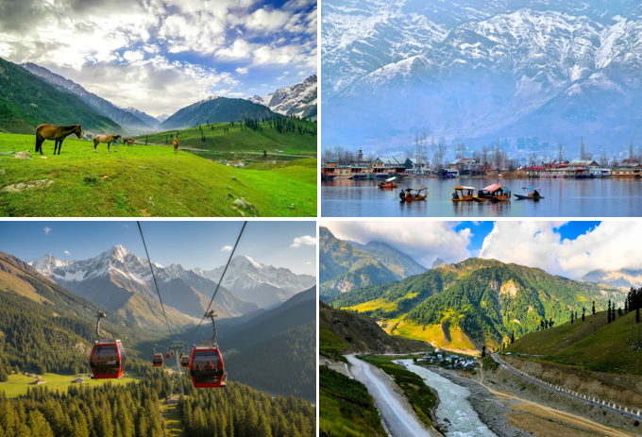

We wish you a happy, safe and unforgettable journey with us

Detailed Itinerary

Day 01: Arrival Srinagar-Local Sightseeing

Upon arrival at Srinagar International Airport, meet our representative and transfer to your hotel/houseboat. After check-in, proceed for a local sightseeing tour covering the beautiful Mughal Gardens – Chashme Shahi, Nishat Bagh, and Shalimar Bagh. Later, visit the sacred Shankaracharya Temple, offering panoramic views of Srinagar and Dal Lake. En route, explore a local handicraft centre renowned for authentic Pashmina shawls, traditional Kashmiri handicrafts, and hand-knotted carpets. Return to the hotel/houseboat for dinner and an overnight stay in Srinagar.

Day 02: Srinagar-Sonmarg-Srinagar (87 Kms | 2.5 hrs one way)

After breakfast, proceed for a full-day excursion to Sonamarg, also known as the "Meadow of Gold." Enjoy a scenic drive through rolling hills, lush green forests, crystal-clear streams, and picturesque landscapes. En route, stop at Gagangir, a beautiful spot nestled along the Sindh River. Upon arrival, admire the breathtaking beauty of Sonamarg and enjoy an optional visit to Thajiwas Glacier by pony ride, local union cab, or a short trek (at an additional cost). Later, explore the local market at your leisure before returning to Srinagar in the evening for an overnight stay.

Day 03: Srinagar - Pahalgam (97 Kms | 03 hrs)
After breakfast, check out from the hotel and drive to Pahalgam, popularly known as the "Valley of Shepherds." En route, visit Pampore (famous for its saffron fields, seasonal), the historic Awantipora Ruins, and Bijbehara, known as the "Breadbasket of Kashmir," while passing through Anantnag, the second-largest city in the valley. Upon arrival, check in to your hotel and enjoy the scenic beauty of the Lidder Valley. You may also opt for a local union cab to visit Aru Valley, Betaab Valley, and Chandanwari (at an additional cost). Return to the hotel in the evening for dinner and an overnight stay in Pahalgam.
Day 04: Pahalgam - Gulmarg (148 Kms/ 04 hrs)
After breakfast, check out from the hotel and proceed to Gulmarg, the famous "Meadow of Flowers," located at an altitude of 2,440 metres above sea level. Enjoy a scenic drive through charming villages, lush green meadows, and picturesque paddy fields, passing via Tangmarg, the gateway to Gulmarg. Upon arrival, check in to your hotel and explore the breathtaking meadows. Visit the renowned Gulmarg Golf Course (seasonal), one of the highest 18-hole golf courses in the world. You may also enjoy an optional Gondola Cable Car Ride to Apharwat Peak (at an additional cost), offering spectacular views of the snow-capped Himalayan ranges. Spend the remaining time at leisure amidst the serene surroundings before returning to the hotel for dinner and an overnight stay in Gulmarg.
Day 05: Gulmarg - Srinagar (56 Kms/ 2.5 hrs)
After an early breakfast, check out of the hotel and drive back to Srinagar. Upon arrival, check in to a traditional Houseboat on the serene Dal Lake and relax. Later, enjoy a 1-hour Shikara Ride, gliding past floating vegetable gardens, floating markets, handicraft shops, and beautifully crafted wooden houseboats while experiencing the unique lifestyle of the local communities living on the lake. Spend the evening at leisure or explore the nearby local markets for shopping before returning to the houseboat for dinner and an overnight stay in Srinagar.
Day 06: Srinagar -Departure
After a late morning breakfast, we will drive to the airport for your flight home. At the airport the driver will assist you with the luggage and will later drop you at the terminal.
Tour ends with unforgettable memories
Destination/Nights | 3* Hotel Name
Srinagar /02N
Pahalgam /01N
Gulmarg /01N
Srinagar/ 01N
HOTELS DETAILS:

Package Cost:

3★ Hotels: Rs. per person (Based on 6 guests – Double Sharing Basis)

Inclusion: -
- Breakfast and Dinner Included.
- 0 DBL Room on sharing based.
- 0 Nights in Srinagar Hotel.
- 0 Night in Pahalgam Hotel.
- 0 Night in Gulmarg Hotel.
- 0 Night in Super Deluxe Houseboat in Srinagar.
- Boat Ride by Shikara on Lake Dal for 01 Hr.
- Assistance on Arrival.
- Welcome Gift on Arrival.
- 02 Bottle Mineral Water Per Day Per Person.
- All Transfers and S.S tours by AC Tempo Traveler [Pick Up Srinagar – Drop at Srinagar]
Exclusions: -
- 5% GST.
- Flight Tickets are not included.
- Guide.
- Extra meal not included or as per the inclusions given above.
- Vehicle not at disposal.
- No extra pickup or drop included for lunch/sightseeing unless otherwise mentioned in the itinerary.
Note:
- Supplement Cost for Aru, Chandanwari & Beetab Valley at Pahalgam Will be Rs. 3000/-Net Per Cab [Sumo/Eeco/Tavera]
- Supplement Cost for Aru, Chandanwari & Beetab Valley at Pahalgam Will be Rs. 3500/-Net Per Cab [Innova/Scorpio/Xylo]
- Supplement Cost for Chained Vehicle from Tangmarg to Reach Gulmarg Will be Rs. 3500/-Net for Both Sides
- Supplement Cost for Cable Car Ride Upto Phase I will be Rs. 950/-Net Per Person and For Both Phase Will be Rs. 2100/-Net Subject to Availability at The Time of Booking)
- Supplement Cost for ESG Will be Rs. 2500/-Net Per Day (Ex Srinagar)

